STRATEGIC DECISION-MAKING USING POWER-BI

PRE-REPORT SUBMISSION

SUBMITTED TO: DR. ARPIT YADAV

# **NAME: AVANISH CHANDRA**

# **REG. NO: 2023JULB01239**

**TABLE OF CONTENT**

**Table of Figures**

1. **PROBLEM STATEMENT** ------------------------------------------------ **3- 4 Page**
2. **DATA REQUIREMENT** -------------------------------------------------- **4- 5 Page**
3. **DATA COLLECTION** ----------------------------------------------------- **5 Page**
4. **DATA VALIDATION** ------------------------------------------------------ **6- 7 Page**
5. **DATA CLEANING** --------------------------------------------------------- **7- 8 Page**
6. **TOOLS** ----------------------------------------------------------------------- **8 Page**
7. **DASHBOARD** -------------------------------------------------------------- **9 Page**
8. **STORYTELLING** ---------------------------------------------------------- **10 Page**

**Table of Figures**

Figure 1, Data Cleaning, [15 Ways to Clean Data in Excel - The Ultimate Guide](https://exceldashboardschool.com/15-ways-to-clean-data-in-excel/)

Figure 2, Demo Financial Dashboard

1. **Problem Statement**

The goal of this Power BI Dashboard is to analyze the financial performance of a company using the provided Microsoft Sample Data.

To create a visually appealing dashboard that provides an overview of the company's financial metrics enabling to make informed about the sales report.

**Objective of the Power BI Dashboard**

The main objective is to **analyze the financial performance and sales metrics** of the company using the provided dataset. The dashboard will provide insights into key factors affecting sales and profitability, enabling stakeholders to make **data-driven decisions**.

**Specific Objectives:**

1. **Sales Analysis**:
   * Provide a detailed breakdown of sales performance by product categories, outlet types, and locations.
   * Identify top-performing items, categories, and outlets to focus on areas of success.
2. **Performance Insights**:
   * Compare the performance of different outlets based on size, type, and location to understand where to allocate resources.
   * Analyze trends in sales to identify patterns or seasonal spikes.
3. **Customer and Product Insights**:
   * Assess the impact of product features (e.g., fat content, visibility, weight) on sales.
   * Evaluate customer preferences by studying ratings and sales correlations.
4. **Decision Support**:
   * Provide actionable insights for improving inventory management, promotions, and outlet operations.
   * Help identify underperforming outlets or categories that need intervention.
5. **Data Visualization**:
   * Create an intuitive, visually engaging dashboard that simplifies complex data into easily digestible insights.
   * Enable stakeholders to explore data dynamically through filters and interactive visuals.

**Expected Outcomes**

1. **Overview**:
   * Visual summary of total sales, average sales per outlet, top categories, and highest-rated items.
2. **Sales Analysis**:
   * Breakdown by item type, fat content, and location tier.
   * Identify top-performing items and outlets.
3. **Outlet Performance**:
   * Compare sales across outlet types, sizes, and locations.
   * Understand how these factors influence sales.
4. **Trends & Patterns**:
   * Visualize sales trends over time.
   * Analyze the impact of item visibility and weight on sales.
5. **Insights for Action**:
   * Recommendations for high-demand items and underperforming outlets.
   * Assess outlet size and tier effects on profitability.
6. **Interactive Features**:
   * Filters for dynamic exploration and drill-throughs for detailed analysis.

**2. DATA REQUIREMENT**

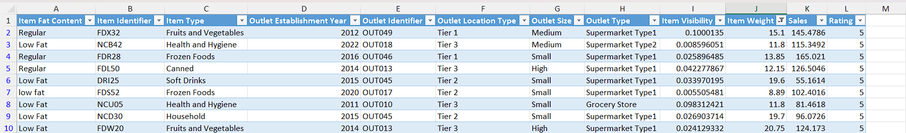

***Source: Kaggle Dataset (*** [***https://www.kaggle.com/datasets/bharathid8/blinkit-sales-dataset***](https://www.kaggle.com/datasets/bharathid8/blinkit-sales-dataset)***)***

**To execute the analysis, the following columns are required:**

1. **Item Fat Content**: Indicates the fat content of the product.
2. **Item Identifier**: A unique identifier for the item.
3. **Item Type**: The category of the item (e.g., Frozen Foods, Soft Drinks).
4. **Outlet Establishment Year**: The year the outlet was established.
5. **Outlet Identifier**: A unique identifier for the outlet.
6. **Outlet Location Type**: The location tier of the outlet.
7. **Outlet Size**: The size of the outlet (Small, Medium, High).
8. **Outlet Type**: Type of outlet (e.g., Supermarket Type1).
9. **Item Visibility**: Visibility of the product in the store.
10. **Item Weight**: Weight of the item.
11. **Sales**: Sales figure for the item.
12. **Rating**: Customer ratings.
13. **Data Collection**

The provided Excel file contains **sample sales data** from a retail or grocery company. The data was derived from the following sources:

1. **Product Information**:
   * Data points such as **Item Identifier**, **Item Type**, **Item Fat Content**, **Item Weight**, and **Item Visibility** were likely collected from the product catalog or inventory management systems.
2. **Sales Records**:
   * The **Sales** column captures sales transaction data, probably sourced from the company's Point-of-Sale (POS) system or financial records.
3. **Outlet Details**:
   * Attributes like **Outlet Identifier**, **Outlet Type**, **Outlet Size**, and **Outlet Location Type** are taken from the outlet database, which categorizes stores based on their characteristics.
   * The **Outlet Establishment Year** suggests the data was enriched with store history information to analyze longevity and performance.
4. **Customer Feedback**:
   * The **Rating** field is likely derived from post-purchase surveys, customer reviews, or in-store feedback systems.
5. **Geographical and Tier Classification**:
   * The **Outlet Location Type** reflects external demographic classifications (e.g., Tier 1, Tier 2 cities) from public or government sources.
6. **Data Validation**

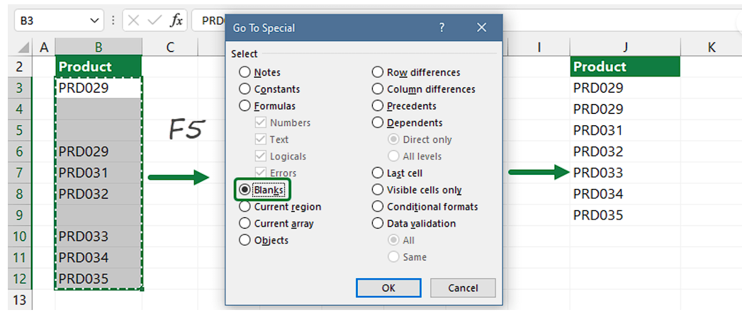**Purpose**: Ensure data accuracy, consistency, and reliability for analysis by identifying and correcting errors or anomalies.

***Figure 1, Data Cleaning,*** [***https://exceldashboardschool.com/15-ways-to-clean-data-in-excel***](https://exceldashboardschool.com/15-ways-to-clean-data-in-excel)

**Steps**

1. **Validate Column Headers**:
   * Confirm headers match the expected schema.
   * Fix missing, extra, or misnamed columns.
2. **Check for Missing Data**:
   * Highlight blank cells.
   * Handle missing values (e.g., impute or remove rows).
3. **Data Type Validation**:
   * Ensure numeric columns (e.g., "Sales") contain only numbers.
   * Check categorical columns for consistent entries.
4. **Check for Duplicates**:
   * Remove duplicate rows to retain unique records.
5. **Validate Numerical Ranges**:
   * Identify outliers in "Sales" and "Item Visibility."
   * Verify reasonable min, max, and average values.
6. **Ensure Categorical Consistency**:
   * Standardize categories (e.g., "Low Fat" and "LF").
7. **Cross-Check Relationships**:
   * Verify logical links (e.g., "Outlet Type" matches "Outlet Identifier").
8. **Data Completeness**:
   * Confirm the dataset covers all expected records and timeframes.
9. **Document Validation**:
   * Log all cleaning actions and detected issues.
10. **Test Final Dataset**:
    * Create test summaries to verify data readiness.
11. **Data Cleaning**

**Purpose**: Ensure the dataset is accurate, consistent, and ready for analysis by eliminating errors and irrelevant information.

**Steps for Data Cleaning**:

1. **Remove Duplicates**:
   * Eliminate repeated rows to avoid distorted calculations.
2. **Handle Missing Values**:
   * Fill numeric fields with mean/median and categorical fields with mode or placeholders (e.g., "Unknown").
3. **Correct Data Types**:
   * Ensure numeric columns (e.g., "Sales") and categorical fields are in the correct format.
4. **Standardize Categorical Values**:
   * Unify inconsistent entries (e.g., "Low Fat" and "LF").
5. **Remove Outliers/Irrelevant Data**:
   * Exclude extreme outliers or irrelevant rows/columns.
6. **Ensure Consistent Units**:
   * Standardize measurements like "Item Weight."
7. **Validate Relationships**:
   * Confirm logical links between fields (e.g., "Outlet Identifier" and "Outlet Type").
8. **Address Formatting Issues**:
   * Trim spaces and ensure consistent text formatting.
9. **Create Derived Fields (Optional)**:
   * Add fields like "Year of Operation" or "Sales per Item" for better insights.
10. **Document Changes**:

* Maintain a log of cleaning actions for transparency and reproducibility.

1. **TOOLS**

**Tools to be Used for Analysis and Visualization:**

1. **Power BI:** For creating interactive dashboards and visualizations.
2. **Microsoft Excel:** For data cleaning, validation, and basic exploratory analysis.
3. 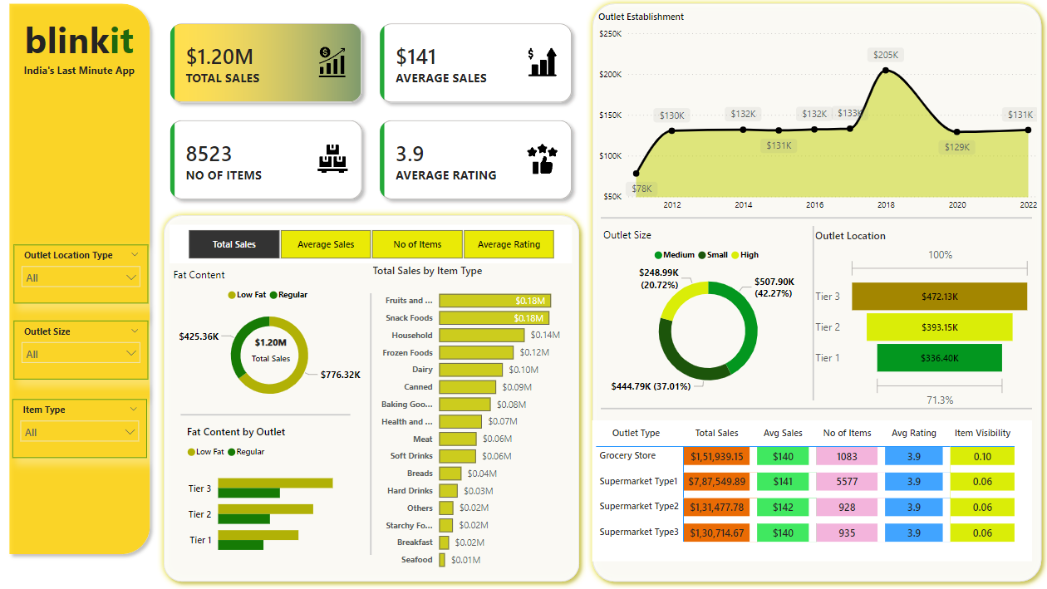**DASHBOARD**

***Figure 2, Demo Financial Dashboard***

**Key Components of the Dashboard:**

From the provided image, the Power BI dashboard visualizes the data using the following key elements:

1. **Total Metrics**:
   * **Total Sales**: $1.20M in overall sales.
   * **Average Sales**: $141 per transaction.
   * **Number of Items**: 8,523 items.
   * **Average Rating**: 3.9 stars.
2. **Filters**:
   * Dropdown filters for "Outlet Location Type," "Outlet Size," and "Item Type" allow dynamic slicing of data.
3. **Visualizations**:
   * **Pie Charts**:
     + Fat content distribution ("Low Fat" vs. "Regular").
     + Sales by outlet size (Small, Medium, High).
   * **Bar Charts**:
     + Sales breakdown by item type.
     + Sales contribution by outlet location type (Tier 1, Tier 2, Tier 3).
   * **Line Chart**:
     + Sales trend over time, mapped by outlet establishment years.
   * **Tables**:
     + Outlet Type-specific metrics (total sales, average sales, number of items, ratings, and item visibility).
4. **STORYTELLING**

**Crafting Insights into a Narrative for Decision-Making:**

**Introduction**

BlinkIt, India's leading last-minute grocery app, uses data-driven insights to improve sales, outlet performance, and customer satisfaction. This summary highlights key findings, challenges, and actionable recommendations to support strategic growth.

**Challenges Identified**

1. **Sales Inequality**:
   * Tier 3 locations lead in sales ($472.13K), while Tier 1 underperforms ($336.40K).
   * Medium-sized outlets dominate revenue ($507.90K), with untapped potential in smaller outlets.
2. **Product Performance Gaps**:
   * Fruits & Vegetables and Snack Foods excel ($0.18M each), but categories like Seafood ($0.01M) lag.
   * Regular-fat products dominate ($776.32K), but low-fat items still hold strong.
3. **Low Visibility & Engagement**:
   * Products have low visibility (0.06–0.10), limiting customer engagement.
   * Average transaction value ($141) leaves room for cross-selling.
4. **Declining Sales Trend**:
   * Sales peaked in 2018 ($205K) but declined to $131K by 2022.

**Key Insights**

* **Medium-sized outlets in Tier 3** drive the highest sales.
* Growth opportunities exist in underperforming categories like Seafood and Breakfast.
* Product visibility and customer satisfaction (3.9/5) require improvement.

**Recommendations**

1. **Expand in Tier 3 and Medium-Sized Outlets**:
   * Scale operations in Tier 3 and improve Tier 1 sales via localized campaigns.
2. **Boost Low-Performing Categories**:
   * Use targeted promotions and vendor collaborations to improve Seafood and Breakfast sales.
3. **Improve Product Visibility**:
   * Redesign store layouts and leverage in-app promotions for high-margin items.
4. **Enhance Customer Engagement**:
   * Introduce bundling, loyalty programs, and personalized offers to boost basket size.
5. **Leverage Historical Trends**:
   * Replicate strategies from 2018’s sales peak and use predictive analytics for growth.
6. **Elevate Customer Experience**:
   * Focus on product quality, availability, and feedback systems to exceed a 3.9 rating.